
Year 9

55

= %

Semester Two Test
Allowed: A4 page of notes and calculators
Time: 55mins

Name: __________________________________________
- What is the probability of getting less than 5 when rolling a dice?
[1 mark]
- $\frac{1}{6}$ b) 67% c) 0.4 d) 73% e) 0.8

- Pond has a surface area of 4m² and a depth of 2m. What is the volume?
- 6m³ b) 2m³ c) 8m³ d) 24m³ e) 12m³
[1 mark]

- The Tangent ratio is found using which of the following?
- Opposite ÷ Hypotenuse b) Adjacent ÷ Hypotenuse c) Adjacent ÷ Opposite
[1 mark]

d) Hypotenuse ÷ Opposite e) Opposite ÷ Adjacent

- Which of the following is 0.0056 written correctly in Scientific Notation?
[1 mark]
- 5.6 x 1000⁻¹ b) 56 x 10⁻³ c) 5.6 x 10⁻³ d) 5.6 ÷ 1000¹ e) 5.6³ x 10
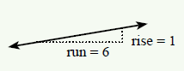

[1 mark]
- What is the gradient of the line above?
- $\frac{1}{6}$ b) 6 d) 16 e) 61 f) 5
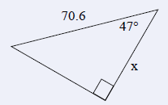

[1 mark]
- What is the name of the side marked with an “x” in the triangle above?
- Adjacent b) Opposite c) Hypothetical d) Tangent e) Hypothesis

- Place the following numbers onto the probability scale.
Impossible Even chance Certain

[3 marks]
20% 0.5 $\frac{7}{10}$ 1 66% $\frac{1}{3}$

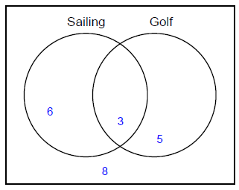
- Use the Venn diagram to answer the following questions?

- How many students like sailing?
[1 mark]

- How many students do not like golf?
[1 mark]

- What is the probability that a student picked at random, does not like either sailing or golf?
[1 mark]

- A recent survey of 1000 car owners is summarised in the table below.
Car type | Frequency
Sedan | 212
Hatchback | 332
Van | 189
Utility | 253
Convertible | 14

- What is the relative frequency of owning a sedan? (as a decimal)
[1 mark]

b) What is the relative frequency of not owning a van? (as a percentage)
[1 mark]

- Using the relative frequencies from the table above, predict how many Utility drivers there would be if there were 75,000 drivers survey.
[2 mark]

- Expand the following.
[5 marks]
  - $4\left(x+2\right)$ = b. $-3\left(2t+2\right)=$

- $\left(g+1\right)\left(g +4\right)=$ d. ${ (2e+3)(e-4)}^{}=$

- Factorise the following.
[2 marks]
  - $6t+2$ b. $12ag+4a$

- The histogram below shows the number of texts students sent each day.
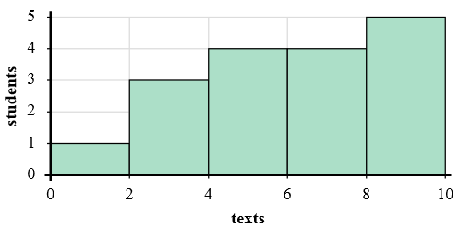
[1 marks]
- Most students sent between _______ and _______ texts.

[1 marks]
- How many students sent between 8 and 10 texts?

[1 marks]
- How many students are represented in this histogram?

4) If a student sent 2 texts which bar would they be added to?
[1 marks]

- The star Sirius is approximately 75 684 000 000 000 km from the Sun.
[1 mark]
- Write this in scientific notation.

The Apollo moon landing rocket could travel at 3.5 x 10⁸ km per year.
[1 mark]
- Write this as a regular number.

- How long would it take to travel to Sirius from the Sun if you were to travel at that speed?
[2 mark]

- Melissa is getting her rectangular back yard paved and at the same time she has also decided to get a pool. The backyard is 12m wide by 17m in length and the pool is also a rectangle that is 9m long by 3m wide.
17m
9m
12m
3m

- What is the size of the area that Melissa needs to get paved?
[1 mark]

- If the pool is 1.5m deep (assume it is 1.5m deep from end to end), what is the volume of the pool?
3m
[1 mark]
1.5m
9m

- How many litres of water will be needed to fill the pool?
[1 mark]

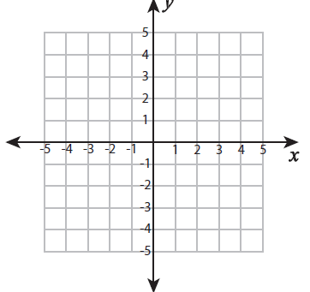
- From the graph to the right;
[1 marks]
  - What are the coordinates of point B?

[1 marks]
  - What is the gradient of the line?
- A
- B

  - How long is the line between points A and B?
[2 marks]

[1 marks]
  - What are the coordinates for the midpoint?

- John is sailing past a navigation marker toward his yacht club. The navigation marker is directly off the coast from a water tower (so the three objects form a right angled triangle as shown below).
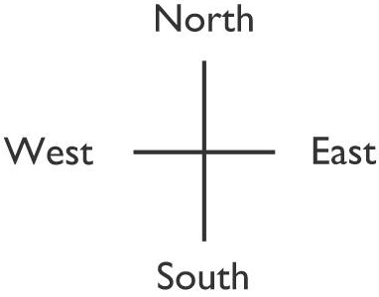
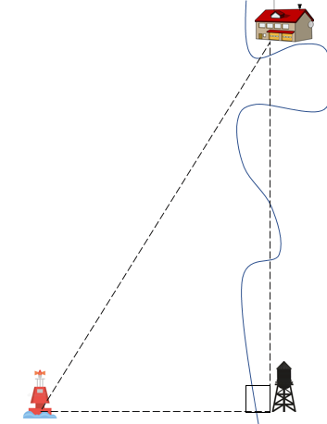
75º
- Label the sides of the triangle above using Opposite, Adjacent and Hypotenuse.
[1 marks]
John checks his chart and can see that there is 2km from the water tower to the navigation marker.
- What rule can John use to find how far he is from the yacht club?
[1 marks]

- Find the distance John needs to travel to arrive at the Yacht club (to 2dp).
[2 marks]

[2 marks]
- Calculate the distance from the water tower to the yacht club (to 2dp).

- If John heads north for 3km (so that he stays 2km offshore), what is the size of the angle formed between the line to the yacht club and the line to the shore (to the nearest degree)?
[2 marks]

- Marcus and Roger were arguing whose basketball team was better. They looked at the high scores from there last season.
Marcus’s team 55, 67, 44, 89, 67, 56, 88, 101, 95, 34, 65, 63, 85, 81, 73
Roger’s team 67, 74, 88, 89, 54, 61, 83, 92, 87, 78, 65, 63, 85, 81, 73
  - Draw a back to back stem and leaf plot.
[4 marks]

 | Range | Median | Mode | Mean
Marcus’s team | 64 | 67 | 56 | 71.1
Roger’s team | 38 | 78 | no mode | 76

  - Based on the the table above, which team do you believe is more successful and why?
[1 marks]

  - Roger’s team plays 1 extra game and only scores 34 points. Describe how this will affect
[3 marks]
    - The mean.

    - The mode

    - The median

End of Test

